JADE Web Services Integration Gateway (WSIG) Guide

USAGE RESTRICTED ACCORDING TO LICENSE AGREEMENT.
Last update: 15-November-2006. JADE 3.4.1
Authors: JADE Board

Copyright (C) 2005 Whitestein Technologies AG

JADE - Java Agent DEvelopment Framework is a framework to develop multi-agent systems in compliance with the FIPA specifications. JADE successfully passed the 1st FIPA interoperability test in Seoul (Jan. 99) and the 2nd FIPA interoperability test in London (Apr. 01).
Copyright (C) 2000 CSELT S.p.A. (C) 2001 TILab S.p.A. (C) 2002 TILab S.p.A. (C) 2003 TILab S.p.A.
(C) 2004 TILab S.p.A (C) 2005 TILab S.p.A
This library is free software; you can redistribute it and/or modify it under the terms of the GNU Lesser General Public License as published by the Free Software Foundation, version 2.1 of the License.
This library is distributed in the hope that it will be useful, but WITHOUT ANY WARRANTY; without even the implied warranty of MERCHANTABILITY or FITNESS FOR A PARTICULAR PURPOSE. See the GNU Lesser General Public License for more details.
You should have received a copy of the GNU Lesser General Public License along with this library; if not, write to the Free Software Foundation, Inc., 59 Temple Place - Suite 330, Boston, MA 02111-1307, USA.

TABLE OF CONTENTS
1 Introduction 2
1.1 Target Audience 3
1.2 Rationale 3
1.3 Current Scope 3
1.4 Current limitations 3
1.5 Requirements 4
1.6 Contact 4
2 JADE WSIG OPERATION 5
2.1 Agent Service published as a Web service endpoint 5
2.2 Web Service published as a JADE agent service 5
2.3 Web Service Invocation by an Agent 6
2.4 Agent Service Invocation by a Web Service 7
3 How to use THE JADE WSIG 9
3.1 Installing the necessary 3rd party software 9
3.2 Configuring and Starting the WSIG 11
3.3 Testing the WSIG 12

Introduction
This document describes the rationale behind the Web Service Integration Gateway (WSIG) and how to install, configure and use it.
The WSIG (version 0.7) is a JADE add-on that provides support for bidirectional invocation of Web services from JADE agents, and JADE agent services from Web service clients. This release should be treated as a beta that is subject to change at any time.
The main body of this guide focuses on the process of starting and configuring the WSIG within a running JADE platform. Some usage examples are also provided. Please refer to the javadoc for a complete description of the APIs that allow programmatic access to the security features.
All bugs, issues and feature requests should be made to the main JADE bug reporting system, or sent to the standard JADE mailing lists.
Version 0.7 of the WSIG add-on was developed by the JADE Board and is only guaranteed to work with JADE release 3.4 or later.

Target Audience
This document is intended for JADE users who are interested in connecting their agent applications with Web services residing outside the JADE platform and use the standard WSDL, SOAP, UDDI Web service protocol stack. The reader is assumed to be familiar with JADE. For those new to JADE we strongly recommend first reading the JADE Administrators Guide and Programmers Guide or the JADE Programming Tutorial, available on the JADE web site (http://jade.tilab.com).

Rationale
Simple yet effective in nature, Web services are fast emerging as the dominant means for connecting remotely executing programs via well established internet protocols and commonly used machine readable representations. A clearly useful of feature of JADE would be a means to search for and invoke Web services directly from application agents. The WSIG meets these needs by providing the means to register Web services in the JADE DF mapped onto FIPA DF agent descriptions. Registered Web services can then be invoked from agents by directing the invocation to the Gateway agent. In addition, the WSIG is engineering to be bidirectional in operation so that Web service clients can also search for and invoke agent services hosted within JADE containers.

Current Scope
The WSIG v0.7 supports the standard Web services stack, consisting of WSDL for service descriptions, SOAP message transport and a UDDI repository for registering Web services using tModels.
The current architecture consists of a JADE agent, called the Gateway agent, which controls the gateway from within a JADE container. This agent uses a set of xerces based codecs to bidirectionally translate ACL/SL0 into WSDL, tModels and SOAP according to the specific context. It also has a socket connection to an Axis Web server from where agent services can be exposed as callable stubs as if they were Web services. The Axis server also receives calls for invocation from external Web service clients onto agent services.
JADE agents can register their services with the normal platform DF and if tagged with type=”wsig” these registrations will be automatically detected by the Gateway agent, converted into WSDL/tModel form and registered with the WSIG UDDI directory. From there they can be discovered by external Web service clients and invoked via stubs exposed through the Axis Web server.
Web services can register directly with the WSIG UDDI repository. These registrations are also automatically detected by the Gateway agent, converted into ACL/SL0 service description and registered with the JADE platform DF. From there they can be discovered by agents and invoked by sending a FIPA Request message to the Gateway agent with the service invocation identity and parameters.

Current limitations
Version 0.7 of the WSIG add-on as described in this document still has some limitations:
- The WSIG is currently designed for use with JADE over J2SE due to the use of third party libraries and technologies. The WSIG has not yet been tested using JADE LEAP, but should work in split container mode.

Requirements
The WSIG requires a JADE v3.4 platform to be running. In addition the WSIG requires the following third party technology to be available on the host system
- Jakarta Tomcat (http://jakarta.apache.org/tomcat/)
- Apache jUDDI (http://ws.apache.org/juddi/)
- mySQL (http://www.mysql.com/)
- MySQL Connector/J (http://www.mysql.com/products/connector/j/)

Additional third party libraries included with the WSIG distribution include:
- Apache Axis v1.4 (http://ws.apache.org/axis/)
- UDDI4J v2.0.5 (http://uddi4j.sourceforge.net/)
- WSDL4J v1.6.2 (http://sourceforge.net/projects/wsdl4j)
- Xerces v2.8.1 (http://xerces.apache.org/xerces-j)

Contact
All issues regarding the JADE WSIG should be addressed to the jade-develop mailing list.

JADE WSIG OPERATION
This section provides an overview of the operations of the WSIG v0.7. Descriptions in the subsections are supported by a coded examples supplied with the WSIG distribution.

Agent Service published as a Web service endpoint
The WSIG allows an agent to publish a service description as a Web service endpoint. This process is described by Figure 1. All the agent need do is set the Type parameter of the agent service description to “web-service”:
sd.setType("web-service")
The DF will use this type specification as a trigger to inform the Gateway Agent to translate the ACL/SL0 service description into WSDL/tModel, register it with the WSIG UDDI and create an endpoint for external Web service clients to invoke the agent service.

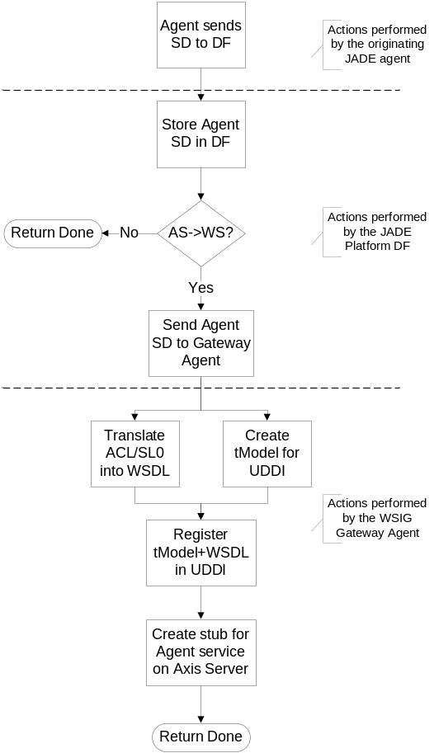
Figure 1: Agent Service Registration with WSIG Gateway

Web Service published as a JADE agent service
The WSIG allows an external Web service to publish a service description as a JADE agent service description with the JADE platform DF. This process is described by Figure 2. The Web service is registered with the WSIG UDDI as it would be with any other UDDI – nothing special is required for WSIG operation. When a new registration is detected the Gateway agent translates it into an equivalent FIPA Directory Entry and sends this as a registration message to the Platform DF.
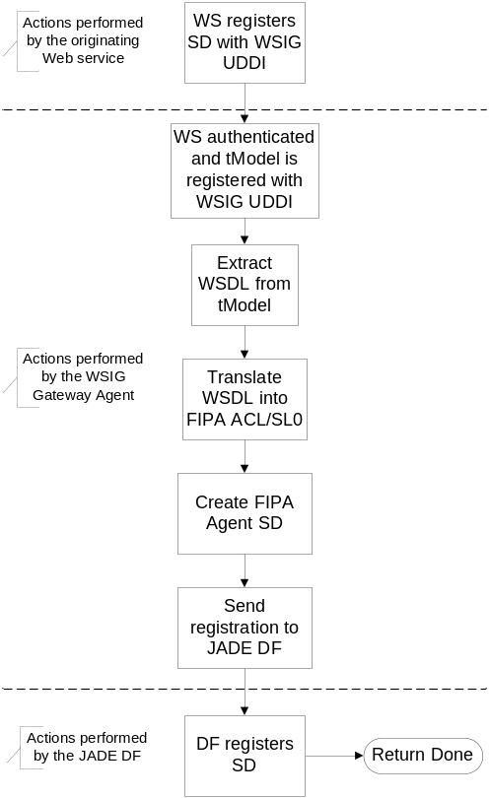
Figure 2: Web Service Registration with WSIG Gateway

Web Service Invocation by an Agent
The process of invoking a Web service that has previously been registered with the WSIG Gateway is described by Figure 3. A JADE agent would first seek the DF service description of the Web service in the platform DF, as it would if discovering an agent service. An invocation request must then be sent to the WSIG Gateway agent as a FIPA Request message. No performatives than FIPA Request and FIPA Inform are treated by the Gateway. The content of the FIPA Request message must contain the identity of the service to be invoked and any necessary parameters. The exact formulation of this message can be seen in the examples provided in package com.whitestein.wsig.test.
When received by the Gateway agent, the FIPA Request is parsed and the presence of an entry in the UDDI repository corresponding to the requested service is verified. If present a SOAP message is created to invoke the Web service, populated with parameters from the FIPA Request and sent to the Web service endpoint. If a response is expected a temporary endpoint is set up on the Axis server. This endpoint is removed once a response is received and has been passed to the Gateway parsers for return as a FIPA Inform to the original sender agent.
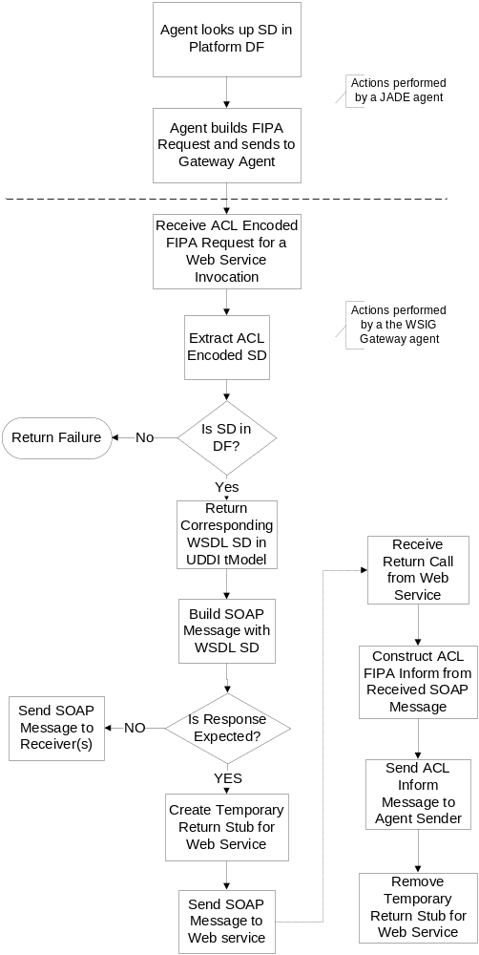
Figure 3: Web Service Invocation initiated by a JADE agent

Agent Service Invocation by a Web Service
The process of invoking an Agent service from an external Web service client is described in Figure 4. It is assumed that the agent service has previously been registered with the WSIG Gateway. A Web service, or Web service client, would first seek the tModel service description of the Agent service in the WSIG UDDI repository, as it would if discovering a Web service. An invocation request is then issued as a SOAP message onto the service endpoint exposed by WSIG Axis server. The content of the SOAP message must contain the identity of the service to be invoked and any necessary parameters. The exact formulation of this message can be seen in the examples provided in package com.whitestein.wsig.test.
When received by the Gateway agent, the SOAP request is parsed and a FIPA Request message created to invoke the Agent service, populated with parameters from the received SOAP message. The FIPA Request is sent to the appropriate agent and if a response is expected, the Gateway agent waits to receive a FIPA Inform from the target agent. Once a response is received it is parsed into a SOAP message and returned to the invoking Web service client.

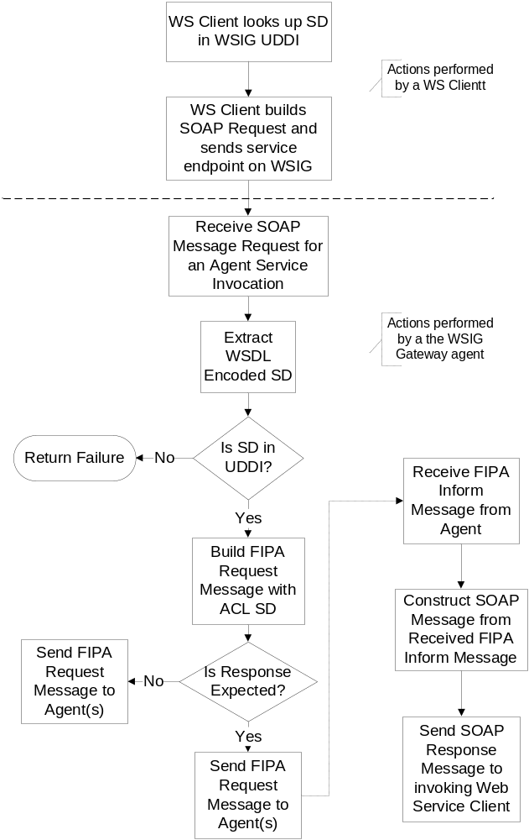
Figure 4: Agent Service Invocation initiated by a Web service

How to use THE JADE WSIG
This section provides instructions of how to set, configure and use the JADE WSIG. All information here is repeated in the various files found in the /misc folder of the WSIG distribution.

Installing the necessary 3rd party software
As indicated previously the following 3rd party software must be installed to use the WSIG:
- Jakarta Tomcat (http://jakarta.apache.org/tomcat/)
- Apache jUDDI (http://ws.apache.org/juddi/)
- mySQL (http://www.mysql.com/)
- MySQL Connector/J (http://www.mysql.com/products/connector/j/)

Download the latest versions of the above software packages and install them on the local machine. WSIG v0.7 has been tested against jUDDI version 0.9.0rc4 (release 0.9rc3 has a wrong database creation script), Tomcat version 5.5.15, MySQL version 5.0 and Connector/J version 5.0.4.
The following procedure should then be followed (repeated in /misc/jUDDI_install.txt):
- Install Jakarta Tomcat
- Install MySQL using setup.exe
  - After installation start mysql\bin\winmysqladmin.exe
  - Enter user account information
- Install jUDDI
  - Copy the ‘juddi’ folder from the ‘webapp’ directory of the jUDDI installation into the ‘webapps’ folder within the Tomcat installation. The copied folder’s name should be set to ‘juddi’.
- Configure the MySQL database using the create_database.sql and insert_publishers.sql scripts as described in the following two steps. These files are found in the sql\mysql directory of the jUDDI directory.
  - Execute ‘mysql\bin\mysql.exe --user=root < create_database.sql’ to create the UDDI tables in mySQL
  - Execute 'mysql\bin\mysql.exe --user=root < insert_publishers.sql’ to create the new publisher required for UDDI queries

- Configure the Tomcat server
  - Copy the library ‘mysql-connector-java-5.0.4.jar’ into the folder %TOMCAT_HOME%\common\lib (where %TOMCAT_HOME% is the folder where you installed Tomcat)
  - Copy the libraries saaj.jar, jaxrpc.jar and juddi.jar into the folder %TOMCAT_HOME%\\webapps\jUDDI\WEB-INF\lib
  - Create a Context element in the Tomcat\conf\server.xml file. If you have the default version of server.xml then you should be able to replace it with the version provided in misc\server.xml which includes the required Context. It is advised to verify that this provided version is consistent with the version provided with your Tomcat installation. Alternatively, you may edit the file %TOMCAT_HOME%\\conf\server.xml directly and include the XML Context element code in the file \misc\tomcatcontext.xml immediately above the </Host> tag in %TOMCAT_HOME%\conf\server.xml.
- Restart Tomcat and verify if the jUDDI installation is functioning correctly at http://localhost:8080/juddi/happyjuddi.jsp.
- Create a UDDI business_key. An example of how to do this is available at: http://www-106.ibm.com/developerworks/webservices/library/ws-uddi4j.html and many other places on the Web. The key that the authors have created for testing is: 8C983E50-E09B-11D8-BE50-DA8FBF3BDC61.
- Add the appropriate business structures in the jUDDI database. These examples use our sample key:
  - Run mysql at the command prompt
  - At the mysql> prompt enter use juddi to switch to the juddi database
  - Enter:
insert into business_name values ("8C983E50-E09B-11D8-BE50-DA8FBF3BDC61", 0, NULL, "Sample WSIG Provider");
insert into business_descr values ("8C983E50-E09B-11D8-BE50-DA8FBF3BDC61", 0, NULL, "Sample WSIG testing provider");
insert into business_entity values ("8C983E50-E09B-11D8-BE50-DA8FBF3BDC61", "John Doe", "jdoe", "jUDDI.org", 20050225150000);
where ‘jdoe’ is your publisher_id as in publisher table and John Doe is your publisher_name;

Configuring and Starting the WSIG
To start the WSIG use the following procedure (repeated from /misc/INSTALL.txt):
- Edit the /misc/wsig.properties file and set as described here. This file is critical to the operation of the WSIG.
  - wsig.host.name = <your_host_name> e.g. localhost
  - wsig.host.port = <port_number> e.g. 2222
  - wsig.agent_id = wsigs@<your_host_name>\:1099/JADE
  - uddi.wsig_businessKey = <businesskey_of_businessentity> see above
  - uddi.userName = jdoe see above
  - uddi.userPassword = <password>
  - uddi.lifeCycleManagerURL= http\://<your_host_name>\:1233/jUDDI/publish
  - uddi.queryManagerURL = http\://<your_host_name>\:1233/jUDDI/inquiry

- To observe the TCP traffic exchanged by the WSIG you can use tcpmon from the Axis project. The file \misc\run_tcpmon_wsig_port is an example of how to initiate a monitor.
  - Note that port numbers must be consistent with those stated in the wsig.properties file
- Equally the file \misc\run_tcpmon_jUDDI provides an example of how to initiate a tcpmon to observe traffic exchanged to and from the jUDDI installation.
  - Note that port numbers must be consistent with those stated in the wsig.properties file
- Start JADE
  - This can be done using the script \misc\run_jade_main
- Start the WSIG
  - Run the script \misc\wsig

The WSIG should now be running in a JADE container and registered with the platform DF.

Testing the WSIG
Two examples are provided for testing the WSIG, one for each direction of operation. Currently these test examples should be run separately, restarting the WSIG before each test. This problem will shortly be resolved by a patch.
- Web Service as server, Agent as client
This example is run via the two files:
- \misc\run_TestSOAPServer to initiate and register a Web service with the WSIG
- \misc\run_TestAgent033 to start a JADE agent to invoke the registered Web service and receive a response

- Agent Service as server, Web service client as client

This example is run via the two file:
- \misc\run_TestAgent001 to initiate and register an Agent service with the WSIG
- \misc\run_TestSOAPClient to start a Web service client to invoke the registered Agent service and receive a response

These examples are supported by several process transcripts available in \misc\examples.

